西圳水东联村
https://m.amap.com/share/index/__q=24.113937964280513,112.80163183808327,%E5%B9%BF%E4%B8%9C%E7%9C%81%E6%B8%85%E8%BF%9C%E5%B8%82%E6%B8%85%E6%96%B0%E5%8C%BAG78%E6%B1%95%E6%98%86%E9%AB%98%E9%80%9F&src=app_share&callnative=1&callapp=0&userRelationToken=7050a4c85c1911eea3b100163e1a69921&lnglat=112.80163183808327,24.113937964280513&name=%E5%B9%BF%E4%B8%9C%E7%9C%81%E6%B8%85%E8%BF%9C%E5%B8%82%E6%B8%85%E6%96%B0%E5%8C%BAG78%E6%B1%95%E6%98%86%E9%AB%98%E9%80%9F
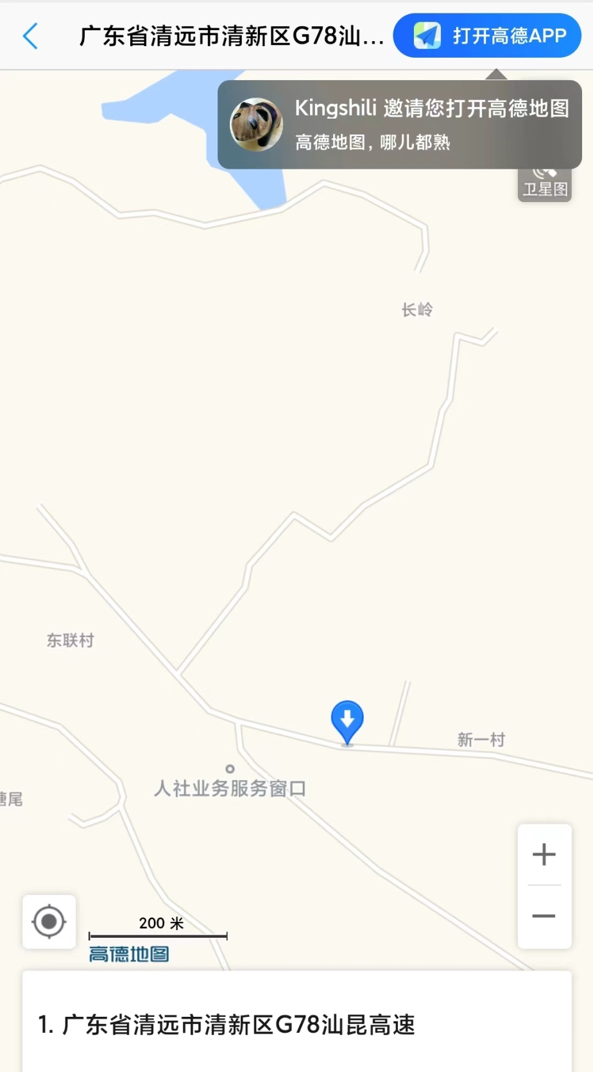
暖水坑新围村
https://m.amap.com/share/index/__q=24.05009401005873,112.78754219412805,%E5%B9%BF%E4%B8%9C%E7%9C%81%E6%B8%85%E8%BF%9C%E5%B8%82%E6%B8%85%E6%96%B0%E5%8C%BA%E5%BB%BA%E8%AE%BE%E8%B7%AF67%E5%8F%B7&src=app_share&callnative=1&callapp=0&userRelationToken=287bc5885c1a11eea0db00163e073e0c1&lnglat=112.78754219412805,24.05009401005873&name=%E5%B9%BF%E4%B8%9C%E7%9C%81%E6%B8%85%E8%BF%9C%E5%B8%82%E6%B8%85%E6%96%B0%E5%8C%BA%E5%BB%BA%E8%AE%BE%E8%B7%AF67%E5%8F%B7
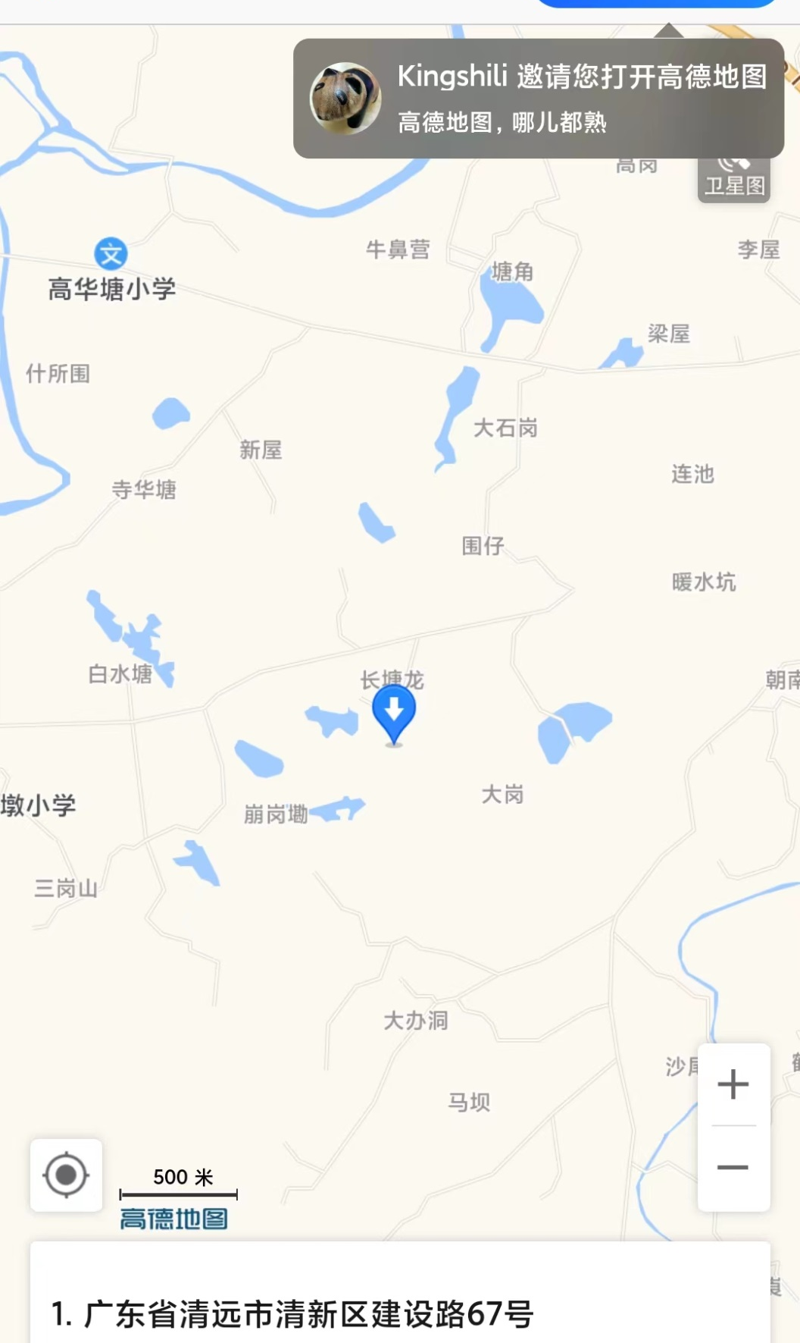
新洲水北社村
https://m.amap.com/share/index/__q=24.000809456548883,112.88793057203294,%E5%B9%BF%E4%B8%9C%E7%9C%81%E6%B8%85%E8%BF%9C%E5%B8%82%E6%B8%85%E6%96%B0%E5%8C%BA%E5%BA%B7%E5%AF%BF%E8%A1%97184%E5%8F%B7&src=app_share&callnative=1&callapp=0&userRelationToken=6369e8a65c1a11eea0db00163e073e0c1&lnglat=112.88793057203294,24.000809456548883&name=%E5%B9%BF%E4%B8%9C%E7%9C%81%E6%B8%85%E8%BF%9C%E5%B8%82%E6%B8%85%E6%96%B0%E5%8C%BA%E5%BA%B7%E5%AF%BF%E8%A1%97184%E5%8F%B7
